Task 1: - Draw a labelled diagram of a typical home WiFi router and a network switch, clearly marking at least 3 different ports (such as WAN, LAN, Console) and the location of status LEDs.
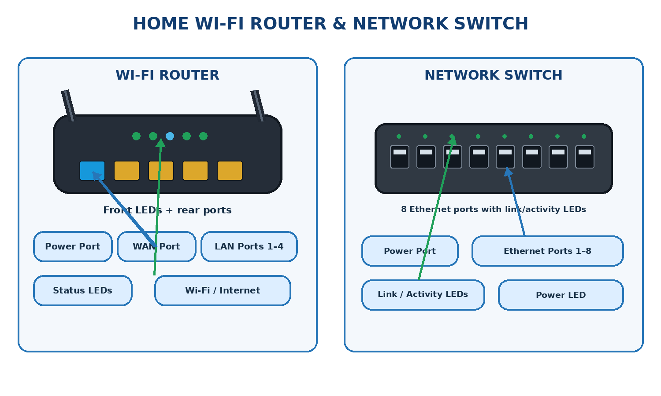

Task 2: - List 3 key differences between routers and switches in terms of their main functions and how they handle network traffic. Think about how each device deals with IP addresses, MAC addresses, and the types of networks they connect.

No. | Router | Switch
1. Main Function | Connects different networks, such as a home network and the internet. | Connects multiple devices within the same local area network (LAN).
2. Addresses Used | Uses IP addresses to determine where to forward packets. | Uses MAC addresses to forward Ethernet frames to the correct device.
3. Network Traffic | Routes packets between different networks and selects an appropriate path. | Forwards frames between devices within a LAN based on its MAC address table.

Task 3: - Take a real or virtual image of a router and a switch (from your home, lab, or Google Images), and identify the following on each: Power port, at least 2 Ethernet ports, and any LED indicators. Annotate the image or describe their position and purpose.
Device | Component and position | Purpose
Router | Power port — rear panel | Connects to the DC power adapter.
Router | WAN port — rear panel | Connects the router to the modem or internet source.
Router | LAN ports — rear panel | Connects wired devices such as computers and printers.
Router | Status LEDs — front panel | Indicate power, internet, Wi-Fi, and LAN connection status.
Switch | Power port — rear panel | Supplies electrical power to the switch.
Switch | Ethernet ports 1–8 — front panel | Connects computers, printers, and other wired network devices.
Switch | Power LED — front panel | Indicates whether the switch is powered on.
Switch | Link/Activity LEDs — beside Ethernet ports | Indicate an active network connection and data transmission.
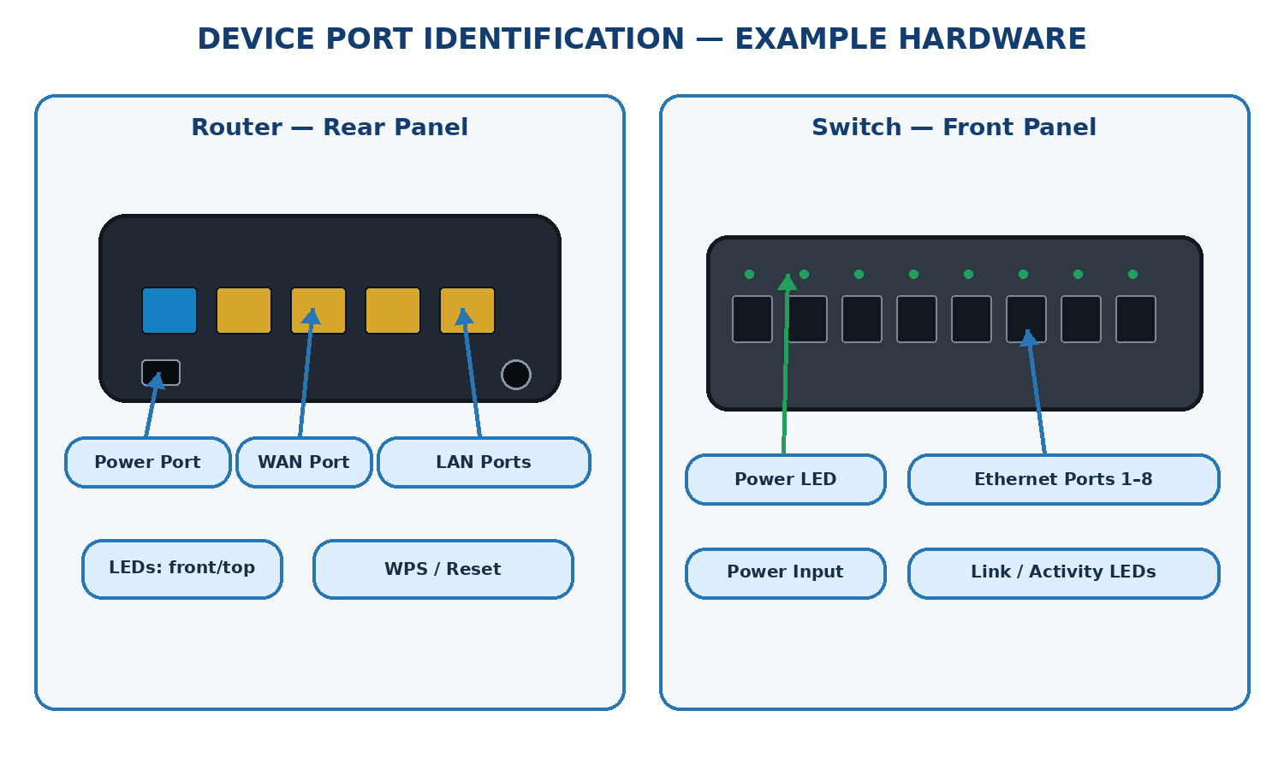

Task 4: - Imagine you are setting up a small gaming café network for IPL streaming and multiplayer matches. Write a short scenario explaining which device (router or switch) you would connect first to the ISP line, and how you would connect 8 gaming PCs to the network. Justify your choices.

1. Scenario
Suppose I am setting up a small gaming café with 8 gaming PCs where customers can play multiplayer games such as Counter-Strike 2, Valorant, and FIFA, while also watching live IPL cricket matches. The café needs a stable, fast, and reliable network to provide a smooth gaming and streaming experience.
To set up the network, I would use an ISP connection, a modem or ONT, a router, a network switch, Ethernet cables, and 8 gaming PCs.
2. Network Setup Diagram
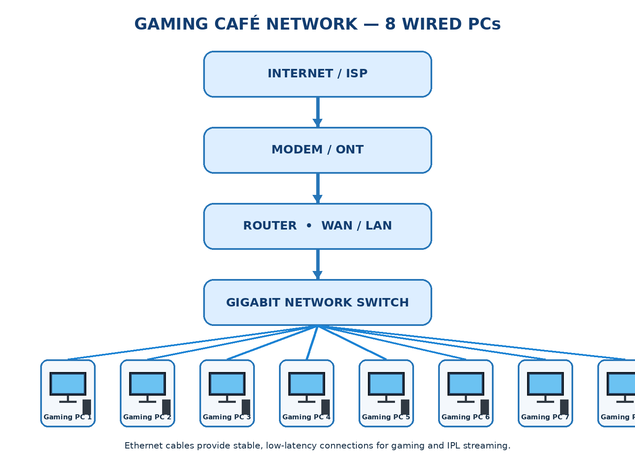
3. Step-by-Step Connection Process
Step 1: Connect the ISP line to the modem or ONT.
The ISP provides the internet connection through fiber-optic cable, coaxial cable, or another supported medium. For a fiber connection, an ONT commonly converts the optical signal into an Ethernet connection.
Step 2: Connect the modem or ONT to the router.
Use an Ethernet cable to connect the modem or ONT output to the router's WAN/Internet port. The router receives the internet connection and manages communication between the café's local network and external networks.
Step 3: Connect the router to the network switch.
Connect a router LAN port to an Ethernet port on the switch. This creates the connection through which the switch can provide network access to all connected gaming PCs.
Step 4: Connect all 8 gaming PCs to the switch.
Use a separate Ethernet cable from each gaming PC to an individual switch port. A 16-port gigabit switch would be a practical choice because it provides enough ports for the 8 PCs and leaves room for a printer, access point, or additional equipment.
Step 5: Configure and test the network.
Configure the router's internet settings, DHCP, firewall, and network security. Confirm that all 8 PCs receive valid IP addresses, can access the internet, and can connect to multiplayer game servers. Test IPL streaming and network performance while several PCs are active.
4. Why Use a Router First and a Switch for the PCs?
Device | Role in the gaming café | Reason
Modem / ONT | Connects the ISP service to Ethernet networking equipment. | Provides the physical internet handoff.
Router | Routes traffic between the café network and the internet. | Provides internet sharing, IP addressing, NAT, and firewall functions.
Network switch | Connects all 8 gaming PCs through wired Ethernet. | Provides multiple ports and efficient local network communication.
Ethernet cables | Connect the PCs to the switch and the switch to the router. | Offer reliable connectivity with low latency and less wireless interference.
5. Important Considerations for Gaming and IPL Streaming
- Low latency: Wired Ethernet connections reduce interference and usually provide more consistent latency than Wi-Fi.
- Sufficient bandwidth: Choose an ISP plan that can handle simultaneous gaming, streaming, and other customer traffic.
- Quality of Service (QoS): If supported, configure traffic prioritization carefully so that streaming or large downloads do not unnecessarily disrupt gaming.
- Network capacity: Gigabit Ethernet ports are a good starting point for the switch and router. Consider faster uplinks if the café grows.
- Security: Use a firewall, strong administrator credentials, and appropriate network segmentation to isolate customer devices from management systems.
Conclusion
I would connect the ISP line to the modem or ONT first, then connect it to the router, and connect the router to a network switch. Finally, I would connect all 8 gaming PCs to the switch using individual Ethernet cables.
This arrangement provides centralized internet management, reliable wired connectivity, and room for expansion, making it suitable for multiplayer gaming and IPL streaming in a small gaming café.

